**Assignment Submission Template**

**1. Student Registration Information**

* **Full Name**: Katelyna J. Pastrana
* **Student ID**: KJP24H
* **Course Name**: CS4813 Web Applications Programming
* **Instructor Name**: Dr. Ahsan Abdullah
* **Date of Submission (mm-dd-yyy)**: 06-18-2025

**1. Assignment Overview (0.5 Points)**

* **Title:** Nested Navigation Menu
* This assignment demonstrates the incorporation of CSS alongside JavaScript and HTML.
* <https://kjphw.github.io/NestedMenu/index.html>

**✅ Requirement:**

* Title is present



* Objective clearly stated in 1–2 sentences



**2. Code Implementation (2.0 Points)**

index.html:

<!DOCTYPE html>

<!--

Click nbfs://nbhost/SystemFileSystem/Templates/Licenses/license-default.txt to change this license

Click nbfs://nbhost/SystemFileSystem/Templates/Other/html.html to edit this template

-->

<html>

<head>

<meta charset="UTF-8">

<meta name="viewport" content="width=device-width, initial-scale=1.0">

<link rel="stylesheet" href="style.css"/>

<title>Nested Menu Navigation Webpage</title>

</head>

<body>

<script src="buttonstuff.js"></script>

<h1>Katelyna's Favorite Subjects</h1>

<br>

<div class="button">

<div class="subject1" onclick="dropdown('.ComputerScience')" style="cursor:pointer;">

<h2 class="grey">Computer Science</h2>

</div>

</div>

<div class="ComputerScience" id="cs-dropdown" style="display: none;">

<a href="programming.html" style="text-decoration:none;">

<div class="items1"><h2 class="grey">Programming Languages</h2></div> <br>

</a>

<a href="erdiagrams.html" style="text-decoration:none;">

<div class="items1"><h2 class="grey">ER Diagrams</h2></div> <br>

</a>

<a href="datastructures.html" style="text-decoration:none;">

<div class="items1"><h2 class="grey">SQL Table</h2></div> <br>

</a>

<a href="dmlinput.html" style="text-decoration:none;">

<div class="items1"><h2 class="grey">DML Input</h2></div>

</a>

</div>

<br>

<div class="button">

<div class="subject2" onclick="dropdown('.Art')" style="cursor:pointer;">

<h2 class="grey">Art</h2>

</div>

</div>

<div class="Art" id="art-dropdown" style="display: none;">

<a href="sketches.html" style="text-decoration:none;">

<div class="items2"><h2 class="grey">Sketches</h2></div> <br>

</a>

<a href="practice.html" style="text-decoration:none;">

<div class="items2"><h2 class="grey">Practice</h2></div> <br>

</a>

<a href="photography.html" style="text-decoration:none;">

<div class="items2"><h2 class="grey">Photography</h2></div> <br>

</a>

<a href="awards.html" style="text-decoration:none;">

<div class="items2"><h2 class="grey">Awards</h2></div>

</a>

</div>

<br>

<div class="button">

<div class="subject3" onclick="dropdown('.TV')" style="cursor:pointer;">

<h2 class="grey">Rating Shows</h2>

</div>

</div>

<div class="TV" id="tv-dropdown" style="display: none;">

<a href="thenanny.html" style="text-decoration:none;">

<div class="items3"><h2 class="grey">The Nanny</h2></div> <br>

</a>

<a href="thegooddoctor.html" style="text-decoration:none;">

<div class="items3"><h2 class="grey">The Good Doctor</h2></div> <br>

</a>

<a href="geekgirl.html" style="text-decoration:none;">

<div class="items3"><h2 class="grey">Geek Girl</h2></div> <br>

</a>

<a href="schoolspirits.html" style="text-decoration:none;">

<div class="items3"><h2 class="grey">School Spirits</h2></div>

</a>

</div>

</body>

</html>

style.css:

/*

Click nbfs://nbhost/SystemFileSystem/Templates/Licenses/license-default.txt to change this license

Click nbfs://nbhost/SystemFileSystem/Templates/ClientSide/css.css to edit this template

*/

/*

Created on : Jun 17, 2025, 7:33:21 AM

Author : katelynapastrana

References : https://www.youtube.com/watch?v=wx5Be8G8Zbo,

https://stackoverflow.com/questions/11777598/font-size-relative-to-the-users-screen-resolution, and

https://www.geeksforgeeks.org/html/how-to-insert-spaces-tabs-in-text-using-html-css/

*/

.button {

display: flex;

align-items: center;

justify-content: center;

margin-bottom: 12px;

}

/* Common style for subject buttons */

.subject1, .subject2, .subject3 {

color: grey;

font-size: 20px;

border-radius: 20px;

width: 90%;

max-width: 600px;

height: 50px;

display: flex;

align-items: center;

justify-content: center;

margin: 0 auto;

}

.subject1 {

background-color: aquamarine;

}

.subject2 {

background-color: lavender;

}

.subject3 {

background-color: lavenderblush;

}

/* Common style for dropdown sections */

.ComputerScience, .Art, .TV {

border-radius: 20px;

width: 90%;

max-width: 600px;

margin: 0 auto 20px auto;

display: flex;

flex-direction: column;

align-items: center;

justify-content: center;

}

/* Individual dropdown backgrounds */

.ComputerScience {

background-color: aquamarine;

}

.Art {

background-color: lavender;

}

.TV {

background-color: lavenderblush;

}

.items1, .items2, .items3 {

color: grey;

font-size: 15px;

border-radius: 20px;

width: 100%;

height: 50px;

display: flex;

align-items: center;

justify-content: center;

margin: 0;

max-width: 580px;

}

.items1 {

background-color: lavenderblush;

}

.items2 {

background-color: aquamarine;

}

.items3 {

background-color: lavender;

}

.home {

background-color: white;

color: aqua;

border-radius: 20px;

width: 10%;

height: 15%;

}

.tab {

tab-size: 4;

color: white;

}

.table, h2, p {color: white;}

.show {

font-size: 3.2vw;

color: white;

text-align: center;

}

.ht {

font-size: 2.0vw;

color: white;

}

.grey {

font-size: 3.0vw;

color: grey;

text-align: center;

}

.back{

color: aqua;

text-align: center;

}

body {

background-color: aqua;

}

h1 {

font-size: 4.0vw;

color: white;

}

buttonstuff.js:

/*

* Click nbfs://nbhost/SystemFileSystem/Templates/Licenses/license-default.txt to change this license

* Click nbfs://nbhost/SystemFileSystem/Templates/ClientSide/javascript.js to edit this template

*/

function dropdown(subject) {

var dropdown = document.querySelector(subject);

if (dropdown.style.display === "none" || dropdown.style.display === subject) {

dropdown.style.display = "flex";

} else {

dropdown.style.display = "none";

}

}

/***********************************************************************************/

/* Name: displayImage */

/* Desription: Displays images. */

/* Date: May 27, 2025 */

/* Author: Katelyna Pastrana */

/* References: https://www.ezmcq.com/ez/show_aia_link.php?kw=web&&city=JavaScript, */

/* https://www.youtube.com/watch?v=hdI2bqOjy3c, Karen Works Lectures in Canvas, */

/* https://www.w3schools.com/jsref/jsref_gethours.asp, Time Changing Images, */

/* https://www.geeksforgeeks.org/how-to-display-images-in-javascript/, and */

/* https://www.w3schools.com/tags/ref_colornames.asp */

/***********************************************************************************/

function displayImage(src, h, w, alt) {

//Creates a new image element

let image = document.createElement("img");

//Set source of image and alt attributes

image.src = src;

image.height = h;

image.width = w;

image.alt = alt;

//Create and aply a centered heading with the image

let div = document.createElement("div");

div.style.textAlign = "center";

div.appendChild(image);

document.body.appendChild(div);

}

programing.html:

<!DOCTYPE html>

<!--

Click nbfs://nbhost/SystemFileSystem/Templates/Licenses/license-default.txt to change this license

Click nbfs://nbhost/SystemFileSystem/Templates/ClientSide/html.html to edit this template

-->

<html>

<head>

<title>Programing Languages</title>

<meta charset="UTF-8">

<meta name="viewport" content="width=device-width, initial-scale=1.0">

<link rel="stylesheet" href="style.css"/>

</head>

<body>

<h1>Programming Languages I Know</h1>

<div class="show">Python</div>

<div class="show">C++</div>

<div class="show">HTML</div>

<div class="show">JavaScript</div>

<div class="show">CSS</div>

<div class="show">MySQL</div>

<br><br>

<a href="index.html" style="text-decoration:none;">

<div class="home" style="cursor:pointer;"> <h2 class="back"> < Back</h2> </div>

</a>

</body>

</html>

erdiagrams.html:

<!DOCTYPE html>

<!--

Click nbfs://nbhost/SystemFileSystem/Templates/Licenses/license-default.txt to change this license

Click nbfs://nbhost/SystemFileSystem/Templates/ClientSide/html.html to edit this template

-->

<html>

<head>

<title>ER Diagrams</title>

<meta charset="UTF-8">

<meta name="viewport" content="width=device-width, initial-scale=1.0">

<link rel="stylesheet" href="style.css"/>

</head>

<body>

<script src="buttonstuff.js"></script>

<h1> Two ER Diagrams I Have Made</h1>

<script>

x=800;

displayImage("ArtworkDatabaseERdiagram.png", 600, x, "Artwork Database ER Diagram"); // From other class

document.write("<br>");

displayImage("ER_Diagram.png", 400, x, "Friend Finder Database ER Diagram"); // From this one

</script>

<a href="index.html" style="text-decoration:none;">

<div class="home" style="cursor:pointer;"> <h2 class="back"> < Back</h2> </div>

</a>

</body>

</html>

datastructures.html:

<!DOCTYPE html>

<!--

Click nbfs://nbhost/SystemFileSystem/Templates/Licenses/license-default.txt to change this license

Click nbfs://nbhost/SystemFileSystem/Templates/ClientSide/html.html to edit this template

-->

<html>

<head>

<title>SQL Table</title>

<meta charset="UTF-8">

<meta name="viewport" content="width=device-width, initial-scale=1.0">

<link rel="stylesheet" href="style.css"/>

</head>

<body>

<h1>I wrote this table for my other class</h1>

<div class='table'>CREATE TABLE pastrana_Buyer (</div>

<div class='tab'> buyerID INT NOT NULL AUTO_INCREMENT,</div>

<div class='tab'> buyerName VARCHAR(30),</div>

<div class='tab'> minBudget INT,</div>

<div class='tab'> maxBudget INT,</div>

<div class='tab'> INDEX (buyerName),</div>

<div class='tab'> PRIMARY KEY (buyerID)</div>

<div class='table'>);</div>

<br><br>

<a href="index.html" style="text-decoration:none;">

<div class="home" style="cursor:pointer;"> <h2 class="back"> < Back</h2> </div>

</a>

</body>

</html>

dmlinput.html:

<!DOCTYPE html>

<!--

Click nbfs://nbhost/SystemFileSystem/Templates/Licenses/license-default.txt to change this license

Click nbfs://nbhost/SystemFileSystem/Templates/ClientSide/html.html to edit this template

-->

<html>

<head>

<title>DML Input</title>

<meta charset="UTF-8">

<meta name="viewport" content="width=device-width, initial-scale=1.0">

<link rel="stylesheet" href="style.css"/>

</head>

<body>

<h1>I wrote this DML for a table in a project in my other class</h1>

<div class='table'>INSERT INTO pastrana_Buyer (buyerName, minBudget, maxBudget) VALUES

<div class='table'>('Jane Doe', 0, 10000),</div>

<div class='table'>('John Doe', 6000, 18000),</div>

<div class='table'>('Juan Diaz', 500, 100000),</div>

<div class='table'>('Maria Diaz', 1000, 500000),</div>

<div class='table'>('Ashley Smith', 200, 1000),</div>

<div class='table'>('Joe Smith', 100, 500),</div>

<div class='table'>('Barbara Alverez', 25, 870000),</div>

<div class='table'>('Juan-Pablo Alverez', 700, 900000),</div>

<div class='table'>('Donald Duck', 100, 4000),</div>

<div class='table'>('Daisy Duck', 10, 1000000);</div>

<br><br>

<a href="index.html" style="text-decoration:none;">

<div class="home" style="cursor:pointer;"> <h2 class="back"> < Back</h2> </div>

</a>

</body>

</html>

sketches.html:

<!DOCTYPE html>

<!--

Click nbfs://nbhost/SystemFileSystem/Templates/Licenses/license-default.txt to change this license

Click nbfs://nbhost/SystemFileSystem/Templates/ClientSide/html.html to edit this template

-->

<html>

<head>

<title>Sketches</title>

<meta charset="UTF-8">

<meta name="viewport" content="width=device-width, initial-scale=1.0">

<link rel="stylesheet" href="style.css"/>

</head>

<body>

<script src="buttonstuff.js"></script>

<h1>Two Sketches I Drew</h1>

<script>

x=300;

y=400;

displayImage("polution.png", x, y, "Polluted Ocean Sketch");

document.write("<br>");

displayImage("dogdress.png", y, x, "Doggy dress idea sketch page");

</script>

<a href="index.html" style="text-decoration:none;">

<div class="home" style="cursor:pointer;"> <h2 class="back"> < Back</h2> </div>

</a>

</body>

</html>

practice.html:

<!DOCTYPE html>

<!--

Click nbfs://nbhost/SystemFileSystem/Templates/Licenses/license-default.txt to change this license

Click nbfs://nbhost/SystemFileSystem/Templates/ClientSide/html.html to edit this template

-->

<html>

<head>

<title>Practice</title>

<meta charset="UTF-8">

<meta name="viewport" content="width=device-width, initial-scale=1.0">

<link rel="stylesheet" href="style.css"/>

</head>

<body>

<script src="buttonstuff.js"></script>

<h1>Depth of Field Practice</h1>

<script>

x=300;

y=400;

displayImage("DSC_1075.JPG", x, y, "Long depth of field");

document.write("<br>");

displayImage("DSC_1073.JPG", x, y, "Short depth of field");

</script>

<a href="index.html" style="text-decoration:none;">

<div class="home" style="cursor:pointer;"> <h2 class="back"> < Back</h2> </div>

</a>

</body>

</html>

photography.html:

<!DOCTYPE html>

<!--

Click nbfs://nbhost/SystemFileSystem/Templates/Licenses/license-default.txt to change this license

Click nbfs://nbhost/SystemFileSystem/Templates/ClientSide/html.html to edit this template

-->

<html>

<head>

<title>Creative Photography</title>

<meta charset="UTF-8">

<meta name="viewport" content="width=device-width, initial-scale=1.0">

<link rel="stylesheet" href="style.css"/>

</head>

<body>

<script src="buttonstuff.js"></script>

<h1>Two Photos</h1>

<script>

x=600;

displayImage("DSC_0370.jpg", x, x, "Forced Perspective");

document.write("<br>");

displayImage("Book_Face.jpg", x, x, "Book face project");

</script>

<a href="index.html" style="text-decoration:none;">

<div class="home" style="cursor:pointer;"> <h2 class="back"> < Back</h2> </div>

</a>

</body>

</html>

awards.html:

<!DOCTYPE html>

<!--

Click nbfs://nbhost/SystemFileSystem/Templates/Licenses/license-default.txt to change this license

Click nbfs://nbhost/SystemFileSystem/Templates/ClientSide/html.html to edit this template

-->

<html>

<head>

<title>Awards</title>

<meta charset="UTF-8">

<meta name="viewport" content="width=device-width, initial-scale=1.0">

<link rel="stylesheet" href="style.css"/>

</head>

<body>

<script src="buttonstuff.js"></script>

<h1>Pieces and The Prizes They Took</h1>

<script>

x=300;

y=400;

displayImage("awardone.png", x, y, "Love is Life's Highlights by Katelyna Pastrana");

</script>

<h2 class="ht">Love is Life's Highlights</h2>

<p>One of life's biggest celebrations is two people becoming one.</p>

<p>

This piece was entered into fourty4fourty and was accepted to hang in the 22nd-floor gallery in the state capital of Florida from January 11th to July 31st 2021. In which it received an honorable mention.

</p>

<script>

displayImage("awardtwo.png", x, y, "Kitty on a Stroll by Katelyna Pastrana");

</script>

<h2 class="ht">Kitty on a Stroll</h2>

<p>A majestic tiger that calls the Bronx Zoo home.</p>

<p>

This piece was entered into the 2021 Walton County fair exhibit, where it received a blue ribbon!

</p>

<script>

displayImage("awardthree.png", y, x, "Childhood Wonder by Katelyna Pastrana");

</script>

<h2 class="ht">Childhood Wonder</h2>

<p>The magic seen by children's eyes is beautiful whether existent or not.</p>

<p>

This piece from my AP 2D Art Studio Sustained Investigation was entered into the 2022 Walton County fair exhibit and received a blue ribbon!

</p>

<a href="index.html" style="text-decoration:none;">

<div class="home" style="cursor:pointer;"> <h2 class="back"> < Back</h2> </div>

</a>

</body>

</html>

thenanny.html:

<!DOCTYPE html>

<!--

Click nbfs://nbhost/SystemFileSystem/Templates/Licenses/license-default.txt to change this license

Click nbfs://nbhost/SystemFileSystem/Templates/ClientSide/html.html to edit this template

-->

<html>

<head>

<title>The Nanny</title>

<meta charset="UTF-8">

<meta name="viewport" content="width=device-width, initial-scale=1.0">

<link rel="stylesheet" href="style.css"/>

</head>

<body>

<script src="buttonstuff.js"></script>

<h1>The Nanny</h1>

<script>

/***************************************************************************************************************/

/* Image Source: Using under Fair Use */

/* https://encrypted-tbn1.gstatic.com/images?q=tbn:ANd9GcRWS_wJ3Y-vIPr3MY62iO12WPtg88eHtK-0iho_z5p1zh5dibUq */

/***************************************************************************************************************/

displayImage("thenanny.jpeg", 550, 366, "The Nanny Show Poster");

</script>

<div class="show">Annoyingly slow-burn rom-com</div>

<div class="show">11/10 Will Watch again</div>

<a href="index.html" style="text-decoration:none;">

<div class="home" style="cursor:pointer;"> <h2 class="back"> < Back</h2> </div>

</a>

</body>

</html>

thegooddoctor.html:

<!DOCTYPE html>

<!--

Click nbfs://nbhost/SystemFileSystem/Templates/Licenses/license-default.txt to change this license

Click nbfs://nbhost/SystemFileSystem/Templates/ClientSide/html.html to edit this template

-->

<html>

<head>

<title>The Good Doctor</title>

<meta charset="UTF-8">

<meta name="viewport" content="width=device-width, initial-scale=1.0">

<link rel="stylesheet" href="style.css"/>

</head>

<body>

<script src="buttonstuff.js"></script>

<h1>The Good Doctor</h1>

<script>

/***************************************************************************************/

/* Image Source: Using under Fair Use */

/* https://www.primevideo.com/detail/The-Good-Doctor/0OO3EI0WX74I0JQ44KM0DGWHPT */

/***************************************************************************************/

displayImage("thegooddoctor.jpg", 480, 640, "The Good Doctor Show Poster");

</script>

<div class="show">Love character development but romances are poorly written</div>

<div class="show">(Not the point of the show but if its going to be there make it good at least)</div>

<div class="show">9/10 A Good Watch</div>

<a href="index.html" style="text-decoration:none;">

<div class="home" style="cursor:pointer;"> <h2 class="back"> < Back</h2> </div>

</a>

</body>

</html>

geekgirl.html:

<!DOCTYPE html>

<!--

Click nbfs://nbhost/SystemFileSystem/Templates/Licenses/license-default.txt to change this license

Click nbfs://nbhost/SystemFileSystem/Templates/ClientSide/html.html to edit this template

-->

<html>

<head>

<title>Geek Girl</title>

<meta charset="UTF-8">

<meta name="viewport" content="width=device-width, initial-scale=1.0">

<link rel="stylesheet" href="style.css"/>

</head>

<body>

<script src="buttonstuff.js"></script>

<h1>Geek Girl</h1>

<script>

/***************************************************************************************************************/

/* Image Source: I am using under Fair Use */

/* https://encrypted-tbn2.gstatic.com/images?q=tbn:ANd9GcQok0Zapii7FmUJG1CbPlarR1ede1UPOjeG9YYI8h6BOsel79I9 */

/***************************************************************************************************************/

displayImage("geekgirl.jpeg", 518, 388, "Geek Girl Show Poster");

</script>

<div class="show">Love! Love! Love!</div>

<div class="show">(Two years after season one to hopefully get season two)</div>

<div class="show">10/10 Can't wait for season two</div>

<a href="index.html" style="text-decoration:none;">

<div class="home" style="cursor:pointer;"> <h2 class="back"> < Back</h2> </div>

</a>

</body>

</html>

schoolspirits.html:

<!DOCTYPE html>

<!--

Click nbfs://nbhost/SystemFileSystem/Templates/Licenses/license-default.txt to change this license

Click nbfs://nbhost/SystemFileSystem/Templates/ClientSide/html.html to edit this template

-->

<html>

<head>

<title>School Spirits</title>

<meta charset="UTF-8">

<meta name="viewport" content="width=device-width, initial-scale=1.0">

<link rel="stylesheet" href="style.css"/>

</head>

<body>

<script src="buttonstuff.js"></script>

<h1>School Spirits</h1>

<script>

/***************************************************************************************************************/

/* Image Source: Using under Fair Use */

/* https://encrypted-tbn3.gstatic.com/images?q=tbn:ANd9GcSPq3zSyD0gqHqesey4LOcoKLGbAzEJqOMzV4CYQ0G5cXnJ6WKa */

/***************************************************************************************************************/

displayImage("schoolspirits.jpeg", 518, 388, "School Spirits Show Poster");

</script>

<div class="show">Very interesting watching as she tries to find out what happened to her</div>

<div class="show">10/10 Starting to watch season two soon</div>

<a href="index.html" style="text-decoration:none;">

<div class="home" style="cursor:pointer;"> <h2 class="back"> < Back</h2> </div>

</a>

</body>

</html>

**✅ Requirement:**

* Code is complete and executable



* Proper indentation and formatting used



* Comments explain major components and logic



**3. Results Screenshot(s) (1.0 Point)**

* *Screenshot of index page.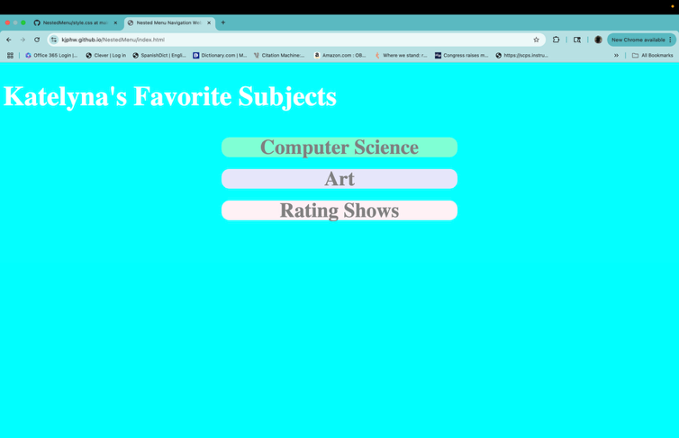*
* *Screenshots of index page with dropdown showing.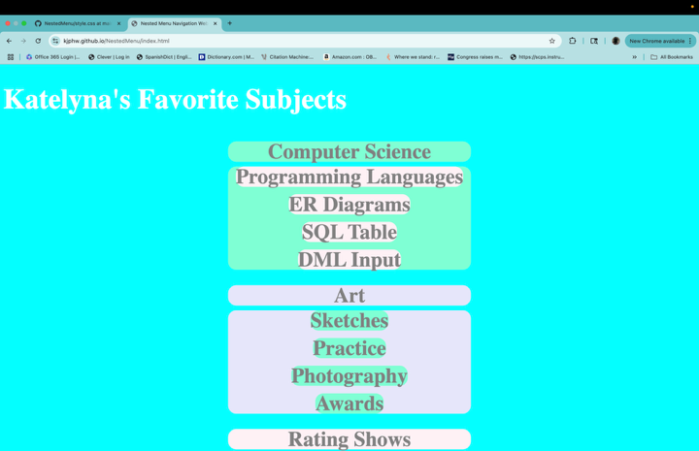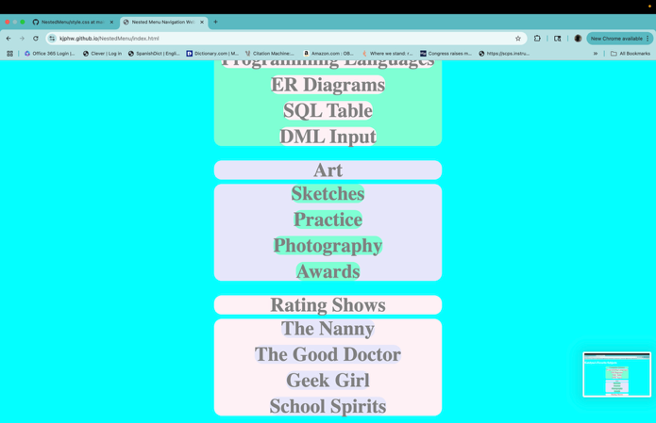*
* *Screenshots of back button functionality.* 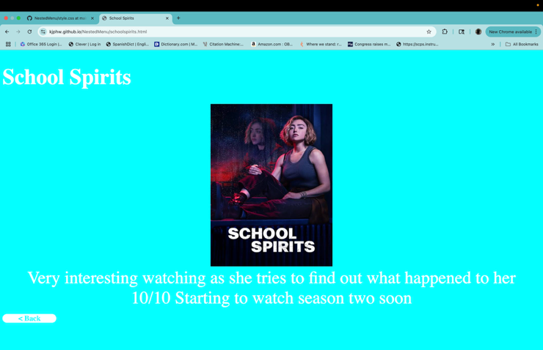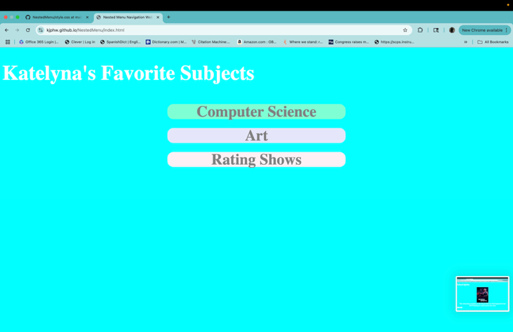
* *Screenshots of other pages.* 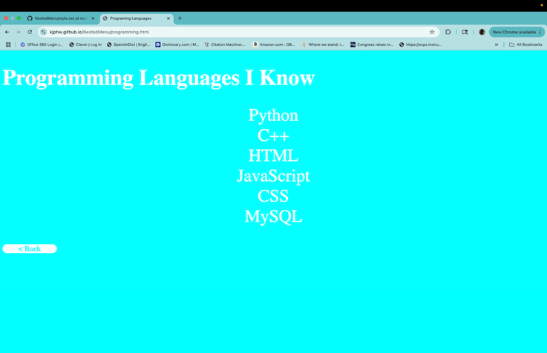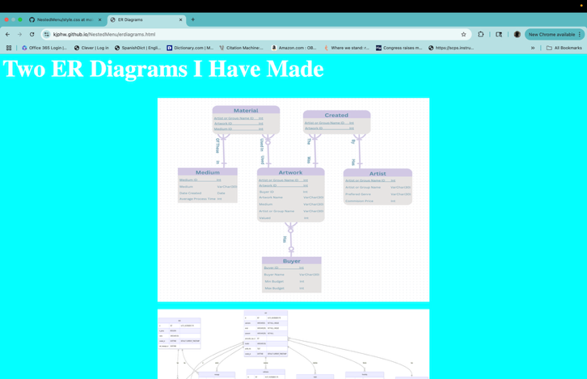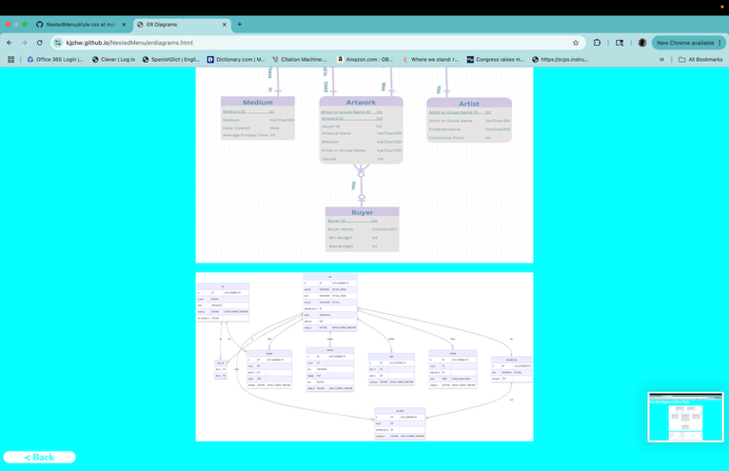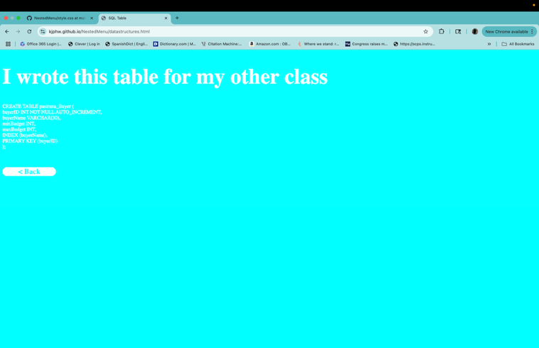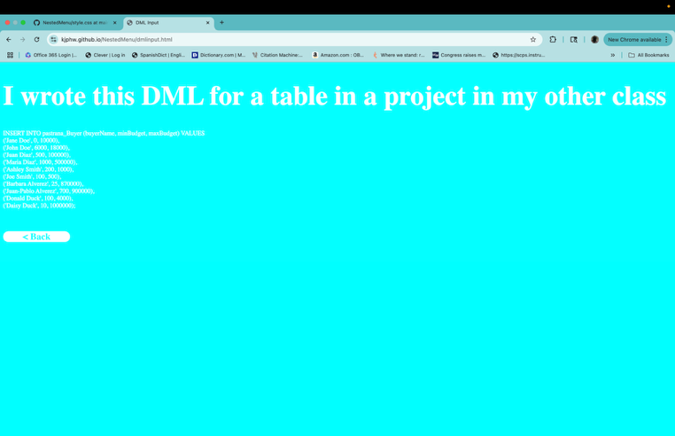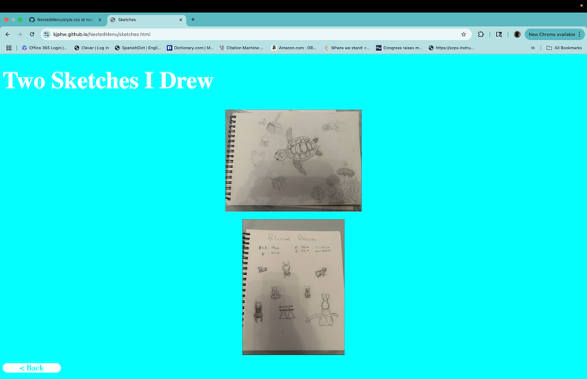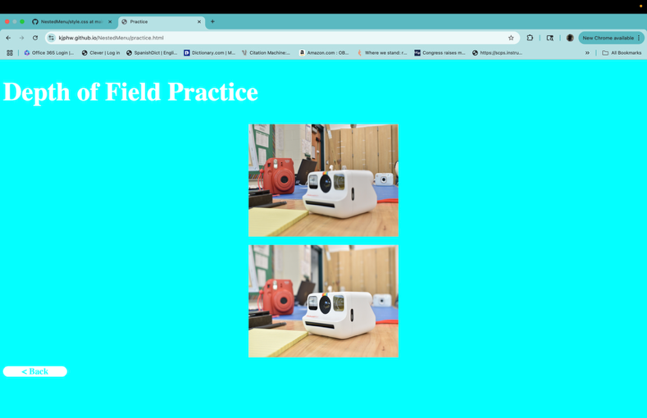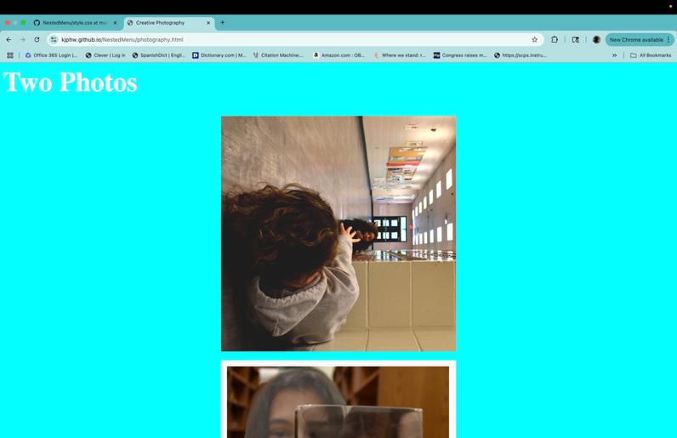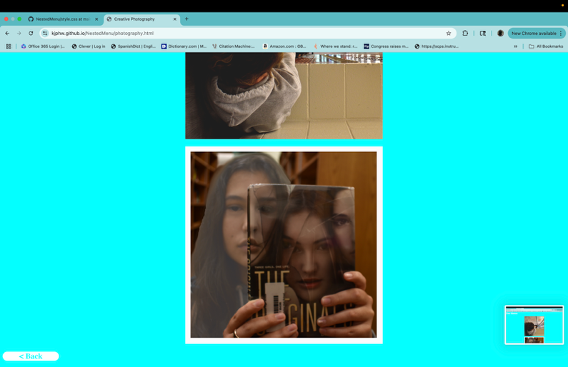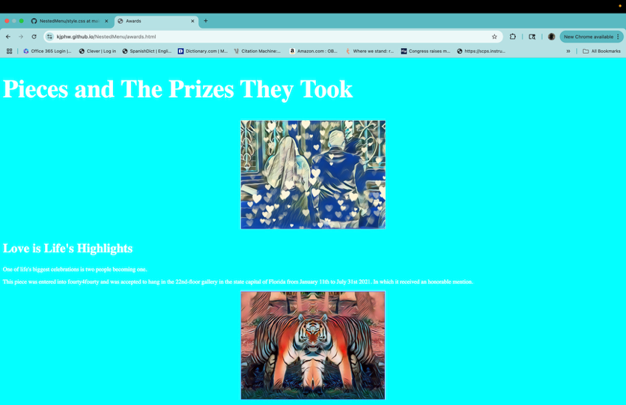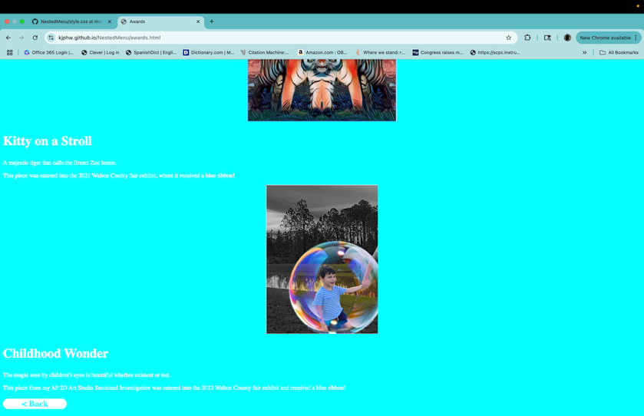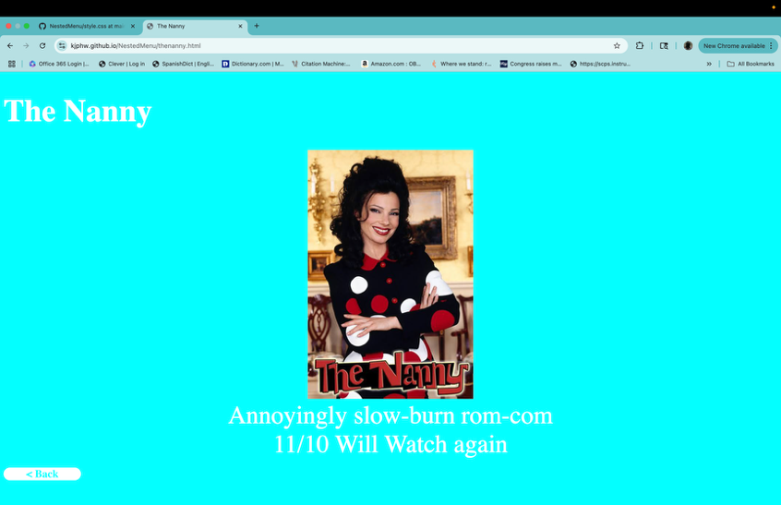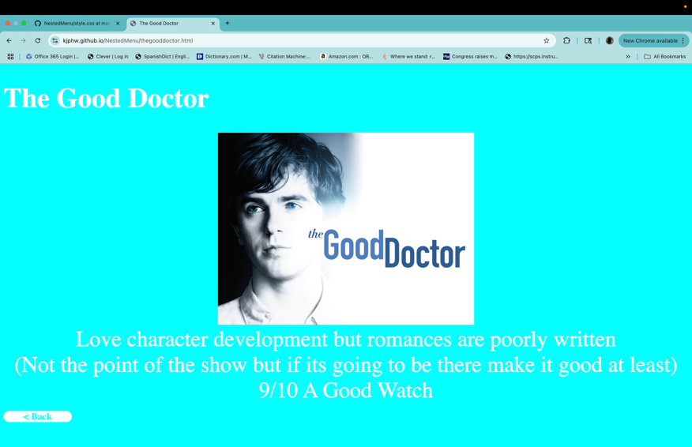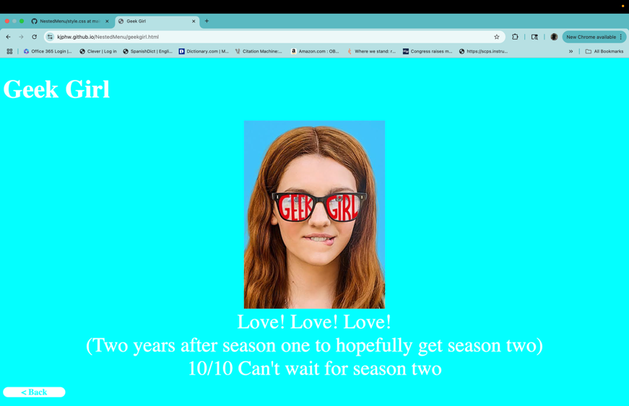

**✅ Requirement:**

* Screenshot(s) showing execution/output provided



* Descriptions accompany screenshots for clarity



**4. Data or Output Results (2.0 Points)**

|  |  |
| --- | --- |
| Button | Website Output |
| Initial Site (no buttons clicked) |  |
| Computer Science button |  |
| Art button |  |
| Rating Shows button |  |
| Programing Languages |  |
| ER Diagrams |  |
| SQL Table |  |
| DML Input |  |
| Sketches |  |
| Practice |  |
| Photography |  |
| Awards |  |
| The Nanny |  |
| The Good Doctor |  |
| Geek Girl |  |
| School Spirits |  |
| Back button |  |

**✅ Requirement:**

* Complete and relevant output included



* Output is clearly formatted and readable



**5. Analysis of Results (1.5 Points)**

* All of the buttons lead where/do they are supposed to, hence the output results are accurate. I feel the layout I choose throughout my pages could use work.

**✅ Requirement:**

* Explanation of results



* Discussion of correctness and any limitations



* Personal reflections or insights



**6. Conclusion (1.0 Point)**

I started with writing the index.html alongside style.css, which I would later realize I should have set up all the html before the CSS to save both time and confusion. I then set up the buttonstuff.js for the dropdown buttons to become flex, later I relized I was using displayimage() in multiple html files and pull it into here. I set up three pages per dropdown, sampling code from my previous projects. I then took pictures for the output above only to realize that I needed one more button in each dropdown and to set up the pages for them. Once I did that I noticed my formatting was not coming out right because a lost track of it while setting up the html. I tried to just fix it but I ended up scraping it and start over. However, that did not solve the main issue which was general html ones were overriding the class related to it. I had to add more classes to resolve the issue and be done.

**✅ Requirement:**

* Clear summary of outcomes



* Reflection on learning or future steps



**7. Key Reflective Questions (1.5 Points)**

* Answer all **three provided reflective questions**.
* Responses should show thoughtful engagement and originality.

1. **Explain a specific part of your code that was most challenging to implement. Why was it difficult, and how did you resolve it?**
   1. The most challenging part to implement was the CSS because I could not figure out why some classes were not working. I resolved by screwing around with it until it clicked that the classes were being overridden and add more classes when rearranging it did not work.
2. **If you had to modify your code to handle an additional feature (e.g., session expiration message or logging login attempts), where would you make the changes and why?**
   1. Depends on where it would appropriately fit, like a button to a new page would go somewhere in index.html.
3. **Describe a mistake you made during development and what you learned from it.**
   1. Painting the walls while still building them is not the way to go.

**✅ Requirement:**

* All reflective questions answered



* Answers are specific, clear, and thoughtful



**8. Additional Comments – Bonus (0.5 Points) *(Optional)***

Finish HTML before doing any CSS!

**✅ Optional Submission:**

* Additional comments or reflections included (for bonus consideration)

